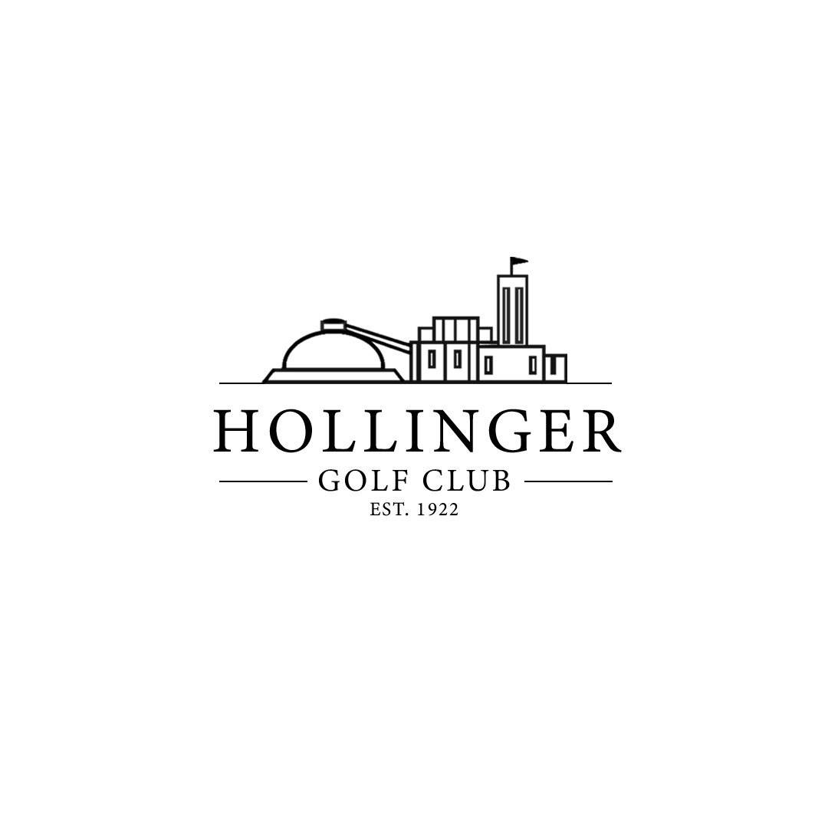

2024
MEMBERSHIP
PACKAGE

555 Moneta Ave. Timmins, ON P4N 7W9
Phone: (705) 264-8450
Email: info@hollingergolf.com

www.hollingergolf.com
Membership Advantages
Thank you for considering Hollinger Golf Club for your golf membership. At the Hollinger Golf Club, our staff strive to ensure you have an enjoyable experience every day you come out to the Club.
Our dedicated staff work hard to provide Members and guests with quality service and playing conditions each day of the season. Our goal is to provide:
“Great Golf, Good Food and Friendly Service!”
Your Golf Operations staff is here to ensure you get the most from your Membership. Our Members will enjoy the club events we host including: Match Play, Club Championship, Ladies’ Night, Men’s night and our Mixed events. If you ever have any questions, our golf operation team will help you find the answer.
Upon completion of your round, be sure to share stories along with a couple of drinks or maybe a bite to eat in our fully licensed clubhouse or on our patio with a great view of the 18th green.
As a Member of the Hollinger Golf Club, you will receive several benefits which include A 7-day advance bookings of tee times. Members receive lower pricing for power carts, range balls, lessons and pro shop merchandise. Members may also purchase a seasonal range membership, a seasonal cart rental or pay an annual trail fee to keep their personal cart and shed on our property.
Thank you for considering the Hollinger Golf Club for your golf membership and please do not hesitate to contact any of our team members for more information.

Regards,

The Hollinger Golf Club Management Team

HOLLINGER GOLF CLUB POLICIES AND PROCEDURES

Privileges

- Members receive discounted pricing on all Pro Shop merchandise.
- Members receive discounted pricing on power cart rentals, pull cart rentals and range balls.
- Members receive discounted pricing on lessons, clinics and club re-gripping.
- Members receive a 25% discount on rental of Clubhouse or tent for meetings & functions.

Membership Term

The annual membership term will be for the season it is purchased for. Golf course opening and closing dates will be set by the management team.

Tee Time Reservations
Members will have the ability to reserve tee times at Hollinger Golf Club up to 7 days in advance by booking with the Pro Shop or in the Chronogolf App.

Tee Time Cancellations

Tee Time Cancellations should be made at your earliest convenience. Effective for the 2024 season, if a member does not cancel his or her tee time 5 hours in advance, or does not show up, we will be issuing a cancellation fee. This fee will be equivalent to the tee time charge, and will be invoiced to the member on a monthly basis, due upon receipt. Cancellation fees owing must be paid prior to
membership renewal for the following season. Cancellations may be made either on the Chronogolf website, or by emailing PROSHOP@HOLLINGERGOLF.COM. Since the Pro Shop phone is busy at all times, phone calls will not be accepted. If you make a booking for a non-member who does not have a credit card on file, and that person does not show up or cancel 5 hours in advance, you will also be
responsible for that cancellation fee. Members should note that non-members who make a booking and do not cancel their tee time within 24 hours will automatically be charged the cancellation fee
using their credit card on file.
Cart Use

Cart use is not mandatory at Hollinger Golf Club. Members may rent carts from the Pro Shop daily for a discount or purchase our Annual Cart Rider service. Members also have the option to pay Trail & Storage fees to keep a personally owned cart & shed on Club property.

Checking-In Before Playing

All Members are required to Check-In with the Starter and/or Pro Shop before every round of golf at the Hollinger Golf Club.

Club Events

All Members are eligible to play in all Club events. Events will have an additional fee and Members must pay the fee to play in an event.

General

Members and their guests must abide by the Hollinger Golf Club’s rules and regulations and respect the rights of all fellow golfers, guests and staff members. Failure to do so may result in the suspension of the Member’s privileges. Suspended Members are not entitled to any refund of the Membership Fee.

No outside alcohol will be permitted on the Club property including the golf course and clubhouse. Any Member or guest of a member found with outside alcohol will be subject to suspension. We reserve the right to check any personal belongings brought onto the property.

2024 ANNUAL MEMBERSHIP APPLICATION

Name: D.O.B. ___ / ___ / _____
M D YEAR
If Couple: Spouse Name D.O.B ___ / ___ / _____
M D YEAR
Address:
City: Postal Code:
Phone #: Cell #:
Email Address:
(Your email address will be held strictly confidential. By providing your email, this gives Hollinger Golf Club permission to send email to your account)

Emergency Contact: Contact #:

Type of Membership:

Please indicate the member ship you are purchasing: ___________________________________________

Waiver

By signing below, I acknowledge that I will follow all policies and procedures as outlined in the Hollinger Golf Club Membership Package. I agree to pay any invoices issued for non-compliance of the newly stated cancelation policy.

Signature Date

Membership Categories
HST INCLUDED IN TOTAL COST
Membership Type | Annual Dues | Member Card | Total Cost
Adult Membership | $1,750.00 | $150.00 | $1,900.00
Couples Membership | $2,985.00 | $300.00 | $3,335.00
9-Hole Weekday Membership (75 & Over) | $1,160.50 | $150.00 | $1,310.50
Young Professional (25 to 30) | $1,301.75 | $150.00 | $1,451.75
Intermediate (19 to 24) | $934.50 | $100.00 | $1.034.50
Junior (13 – 18) | $298.00 | $50.00 | $348.00
Juniors under 12 play free with a paying adult
Afternoon Member - After 3 pm, or 1pm Sat/Sun | $ 1,054.00 | $ 150.00 | $ 1,204.00
Associate Member (Fee plus 40% off tee time) | $ 600.00 | $ 150.00 | $ 750.00

OTHER MEMBER SERVICE FEES
Member Service |  |  | Total Cost
Trail & Storage Fees (Privately Owned Carts) |  |  | $ 650.00
Club Storage (golf bags only, no pull carts) |  |  | $ 110.00
Range Membership (unlimited range balls) |  |  | $ 300.00
Annual Half Cart Rider Membership |  |  | $ 800.00

