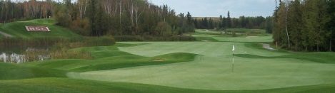
2024 Corporate
Membership Packages

$2,400 plus HST

Option #1: Adult Membership plus 25 18-Hole Golf Passes
- 1 Adult Membership ($1,900 Value)
- 25 Anytime Green Fee Passes ($1,500 Value)
- Discounts on Carts and Driving Range for Adult member
- $150 Pre-Loaded Corporate Business Card
- Company Name displayed at the Club ($565 Value). Note: Sign & artwork is not included (approximately $70 cost at John’s Neon Signs).
- Total Package Savings over $ 1,253!

Option #2: 50 Passes
- 50 Anytime Green Fee Passes ($ 3,000 Value)
- Company Name displayed at the Club ($565 Value). Note: Sign & artwork is not included (approximately $70 cost at John’s Neon Signs).
- $150 Pre-Loaded Corporate Business Card
- Total Package Savings over $ 1,000!

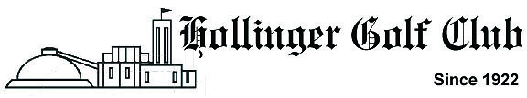

2024 Corporate Membership Application
Company Name: __________________________________
Mailing Address:
Contact Person:
E-mail: Telephone #:

Member Information
Name: D.O.B: ____ / ____ / ____
Address:
City: Postal Code:
Phone #: Cell #:
Emergency Contact:
Contact Phone #:
Email Address:
(Email addresses will be held strictly confidential. By providing your email address, you give Hollinger Golf Club permission to add your email to our contact database)
OFFICE USE BELOW
DATE PAID: METHOD OF PAYMENT:
AUTHORIZED BY:
WELCOME PACKAGE MADE: CORPORATE CARD #:
MEMBER ID:
PACKAGE RECEIVED: DATE:

