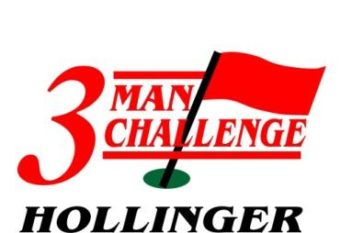
2023 HGC Labour Day 3-Man Challenge
Date:
- Friday September 1st to Sunday September 3rd, 2023
- $235 per player / $705 per team
  - HGC members with a cart membership or trail fee receive discounted price of $190/player)
Includes:
- 3 Rounds of Golf (1 Practice & 2 Tournament Rounds)
- Registration Gift
- Cook your own Steak Dinner on Saturday night
- Large Prize Table
- On Course Prize Contests
- Chance to win a $10,000 Hole-in-One Prize on Saturday

- Registration closes Monday, August 28th at 12:00 pm.
  - Please Note: Players must be 18 years of age to compete in the tournament (exceptions made my management may be permitted)
- Field limited to the first 60 paid teams (180 players)

Please return entry form below to the Hollinger Golf Club Pro Shop with payment. You may call the Pro Shop at 705.264.8450 to register provided you pay via Mastercard or Visa.

2023 Hollinger 3-Man Challenge Presented by Maslack Supply, Nordic Bearings

Team Captain: ___________________ Phone: _________________
E-Mail: _________________________
Player 2: ____________________ Player 3: __________________
Saturday Tee-time preference: AM: _____ PM: ______ (Tee-times Sunday will depend on finish Sat.)
Request to play with: ______________________________________

Shirt Sizes - Small _____ Medium _____ Large _____ X-Large _____ XX-Large _____ XXX-Large ___

